**DAILY ONLINE ACTIVITIES SUMMARY**

|  |  |  |  |  |  |  |  |
| --- | --- | --- | --- | --- | --- | --- | --- |
| **Date:** | **13-06-2020** | | | | **Name:** | **B.A.SOHANKUMAR** | |
| **Sem & Sec** | **4TH SEM A** | | | | **USN:** | **4AL18CS013** | |
| **Online Test Summary** | | | | | | | |
| **Subject** | | **DATA COMMUNICATION** | | | | | |
| **Max. Marks** | | **30** | | **Score** | | **28** | |
| **Certification Course Summary** | | | | | | | |
| **Course** | **DATA SCIENCE WITH PYTHON** | | | | | | |
| **Certificate Provider** | | | **GLA** | **Duration** | | | **11.2 HOURS** |
| **Coding Challenges** | | | | | | | |
| **Problem Statement:1:Write a c program to calculate electricity bill.**  **Problem Statement:2:How to find the first non repeated character of given string.** | | | | | | | |
| **Status: EXECUTED** | | | | | | | |
| **Uploaded the report in Github** | | | | **YES** | | | |
| **If yes Repository name** | | | | **LOCKDOWN CODING** | | | |
| **Uploaded the report in slack** | | | | **YES** | | | |

**ONLINE TEST DETAILS:**

Today's test was on 1st and 2nd module of DATA COMMUNICATION (18CS46).The duration of the test is 30minutes from 02.00pm to 02.30pm.Questions were of multiple choice.Score I received is 28/30.

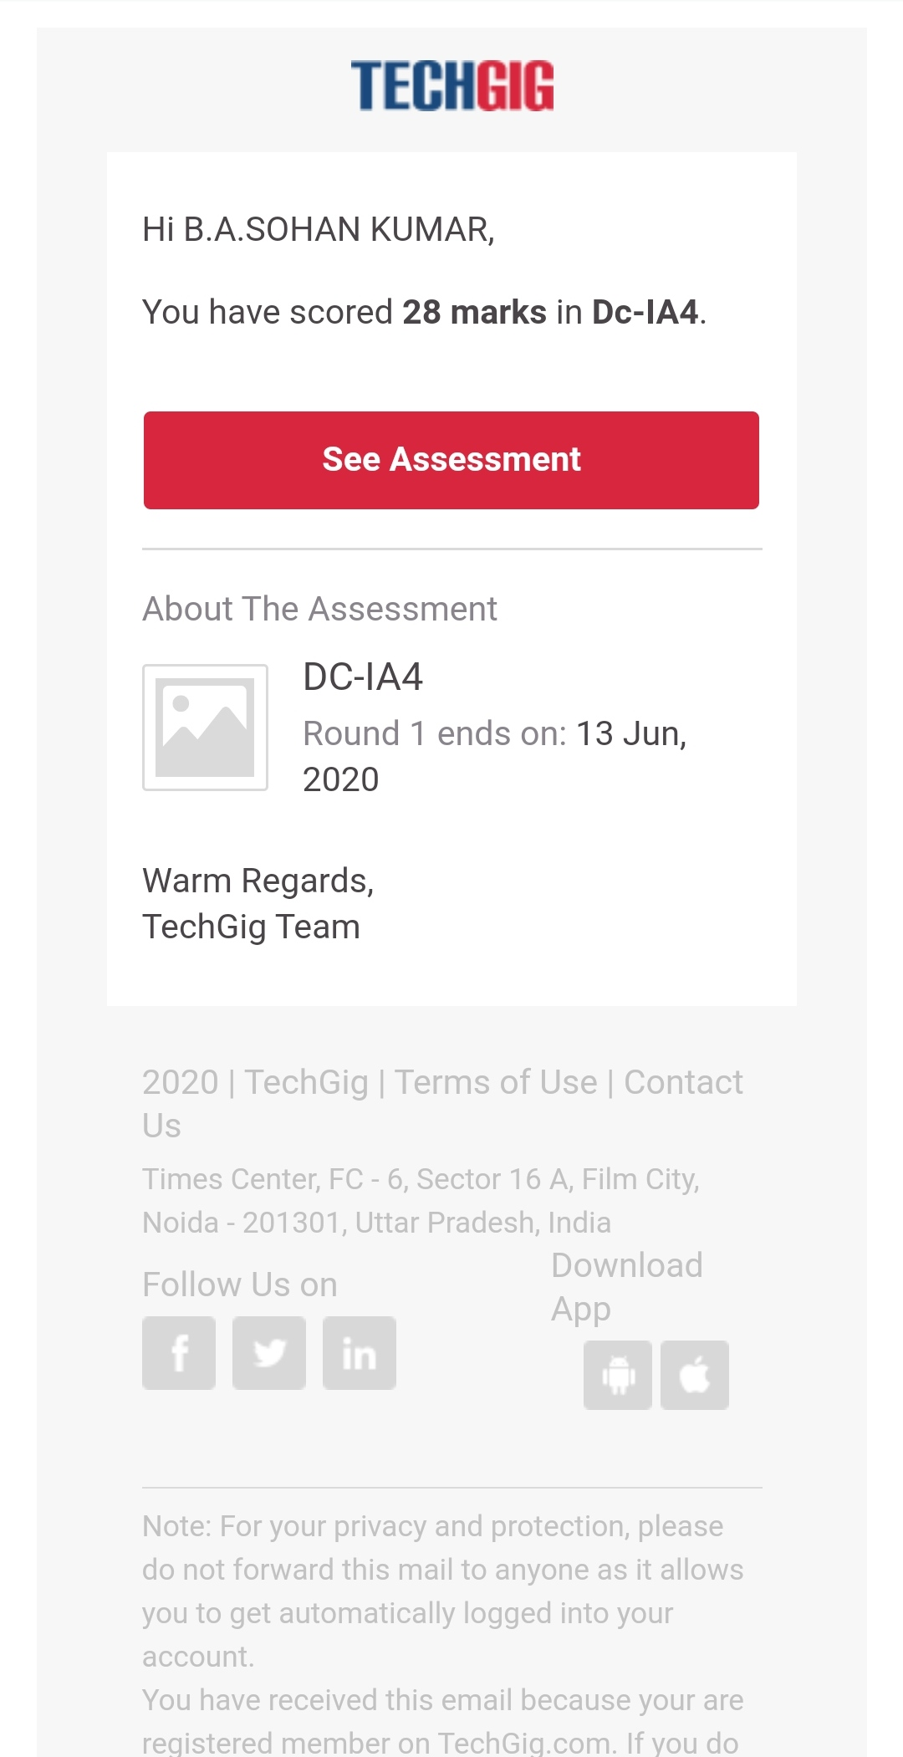

**CERTIFICATION COURSE DETAILS:**

Course:Data science with python

Completed topics are Bi variate statistics,Multivariate statistics(Linear Regression),Intro to Python,Variables in python,Datatypes in python,Operators in python,Strings in python,Tuples,Lists,Dictionary,Set,If statement,Looping while,for loop,Functions,Class, objects,Inheritance,Intro to Numpy array,Numpy Shape,NumpyAarray Arithmetic,Joining numpy array,Series object,Dataframe,Data Visualization-Matplotlib,Intro to Linear Regression,Models and Maths for Linear Regression.

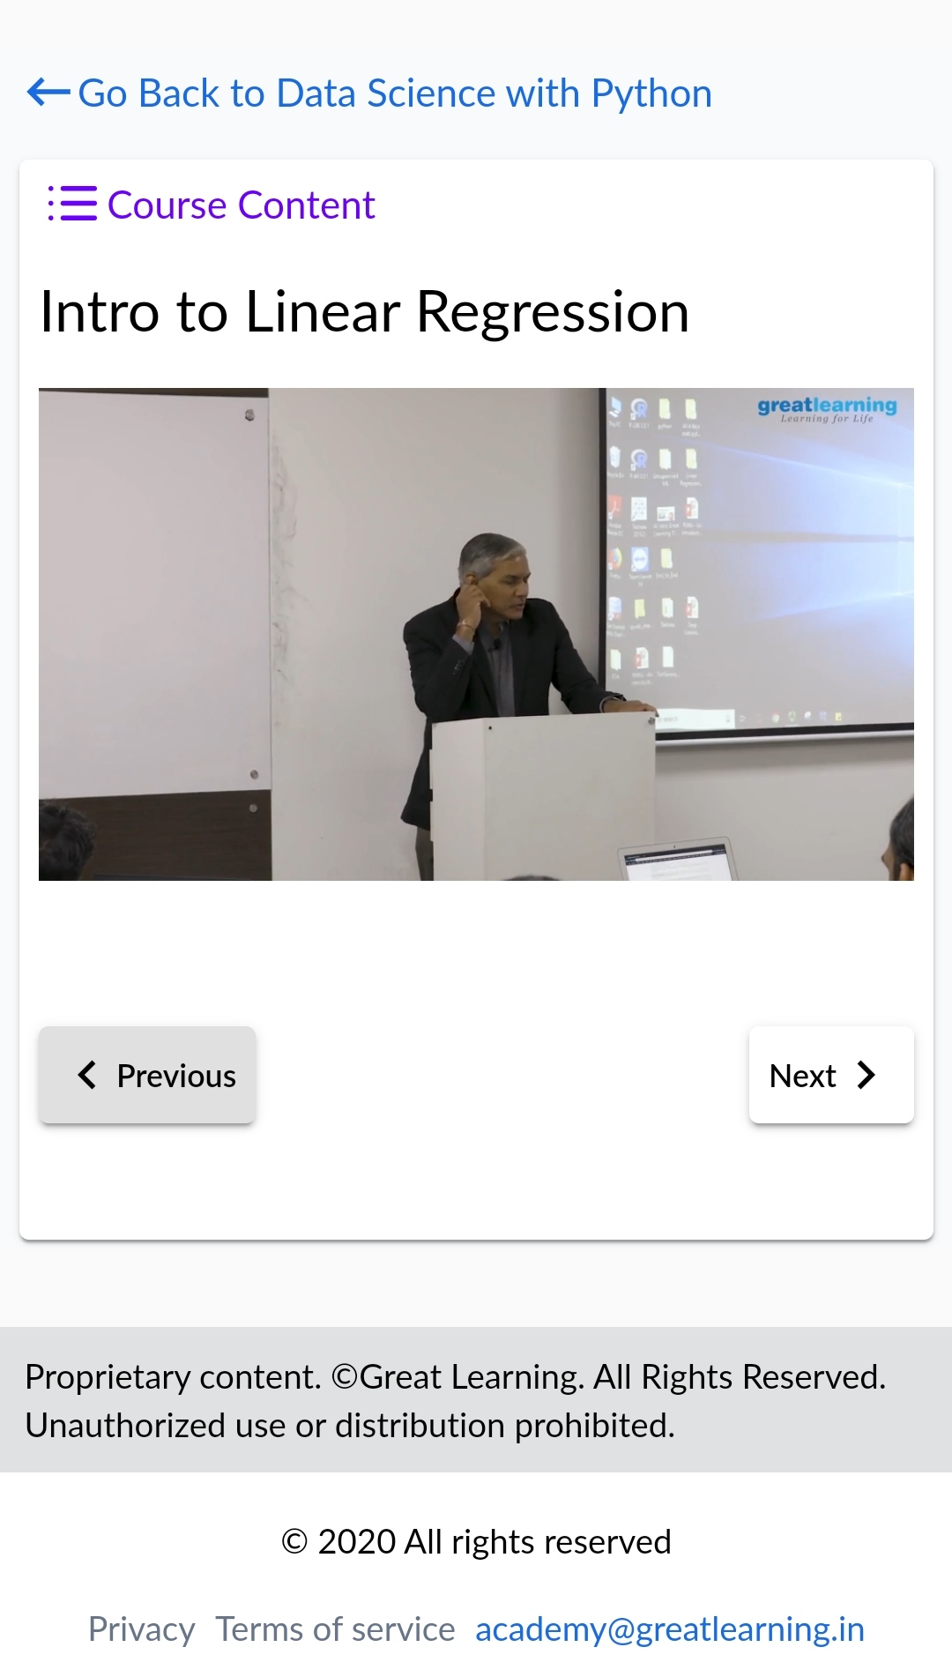 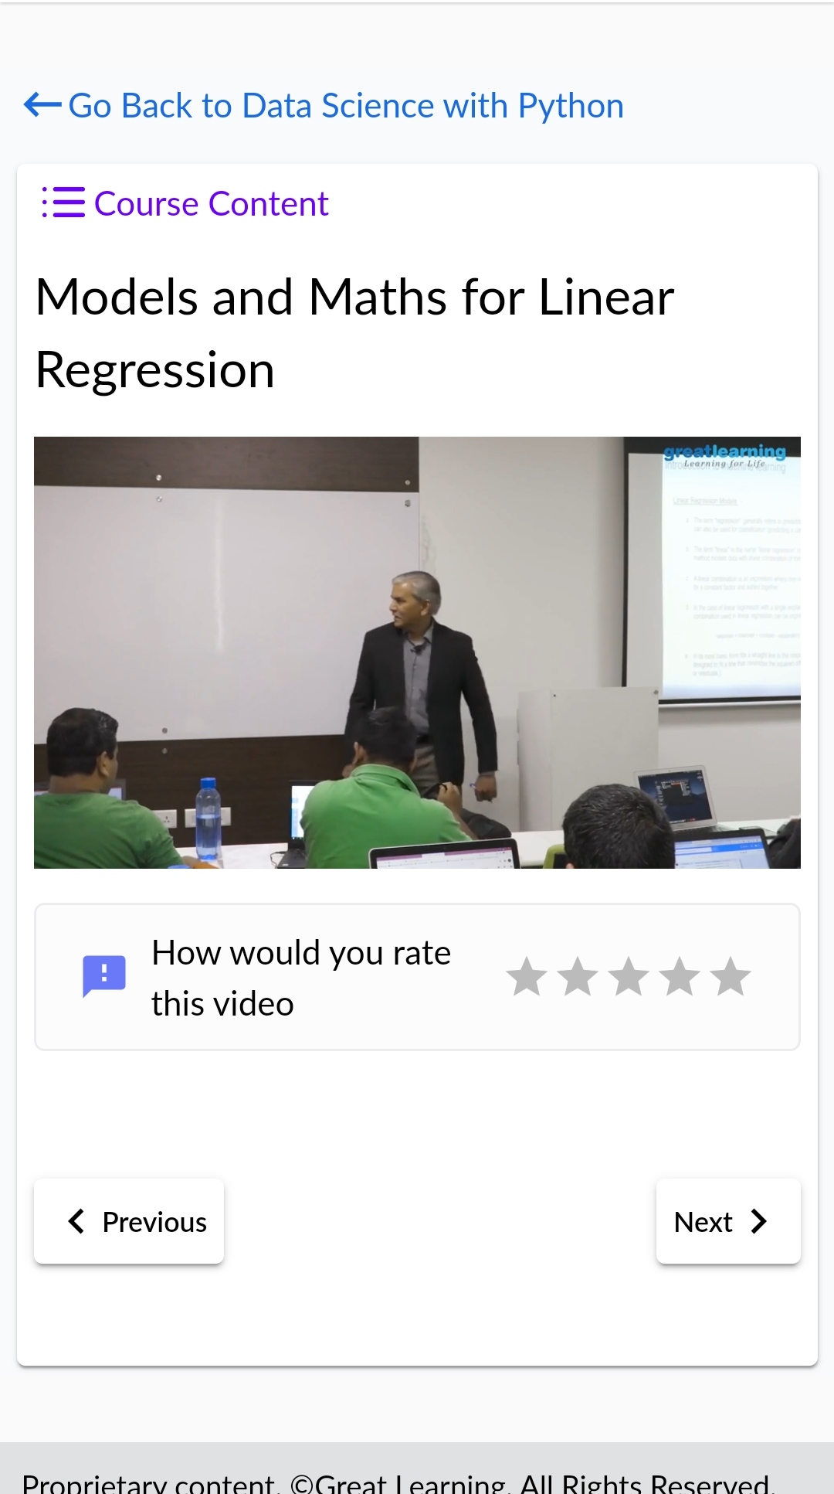

**CODING CHALLENGES DETAILS:**

1.Write a c program to calculate electricity bill.Given an integer U denoting the amount of KWh units of electricity consumed, the task is to calculate the electricity bill with the help of the below charges:

• 1 to 100 units – Rs 10/- Per Unit

• 100 to 200 units – Rs. 15/- Per Unit

• 200 to 300 units – Rs. 20/- Per Unit

• above 300 units – Rs. 25/- Per Unit

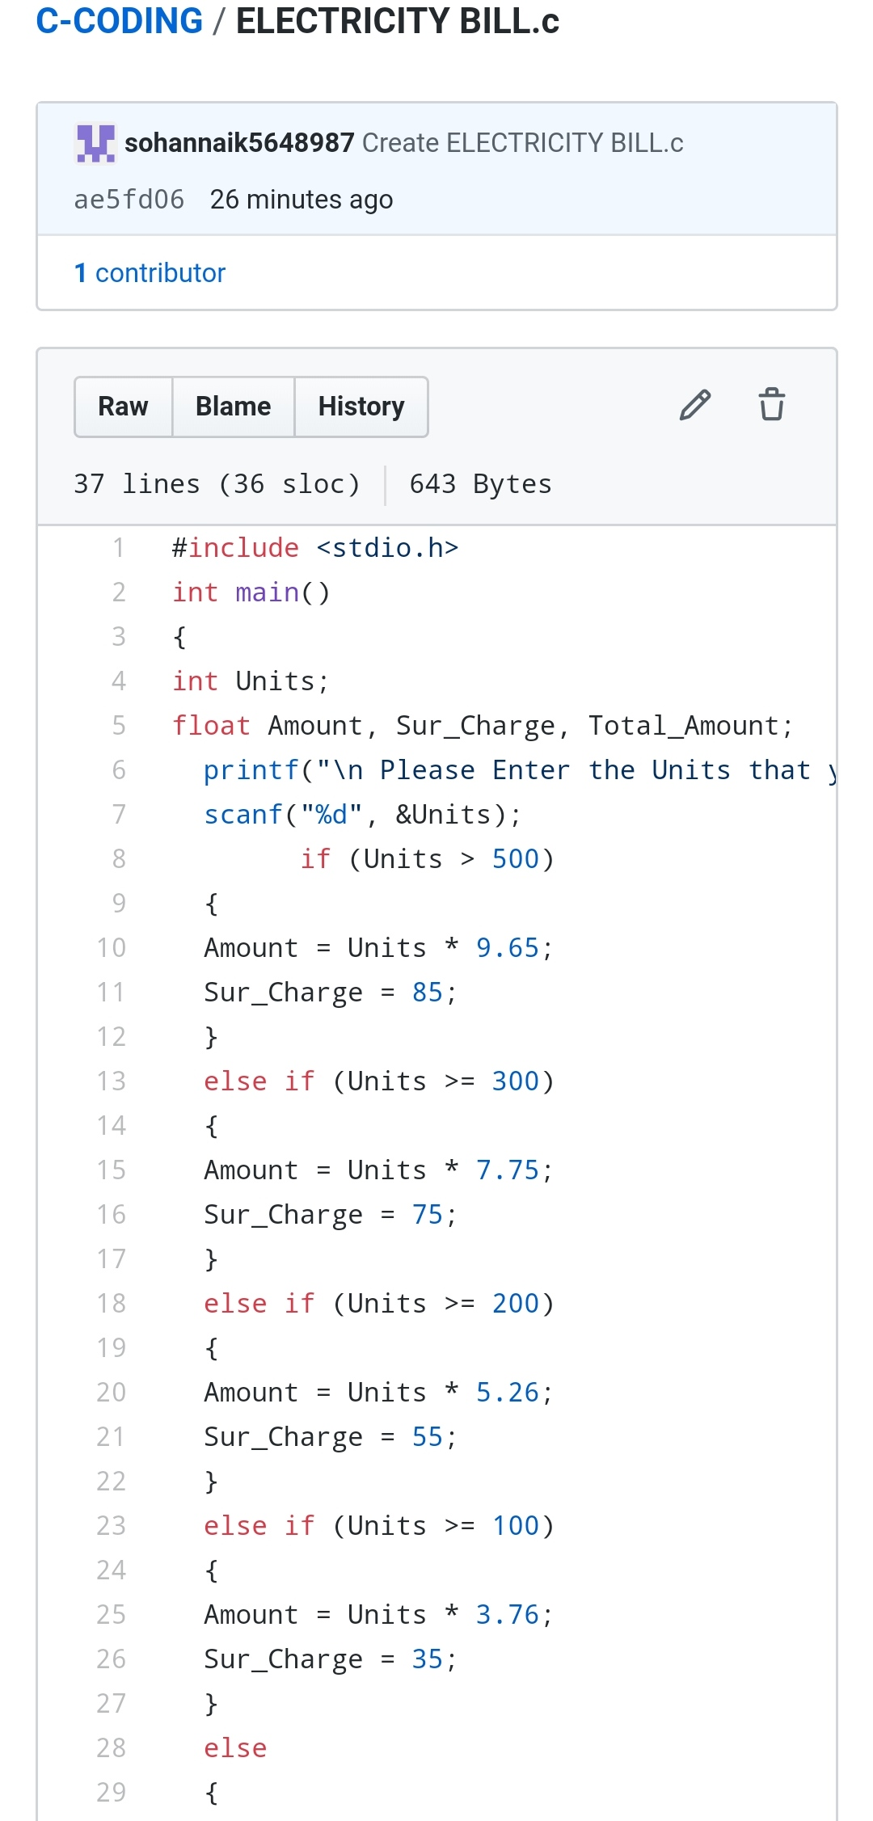

2. How to find the first non repeated character of a given String?

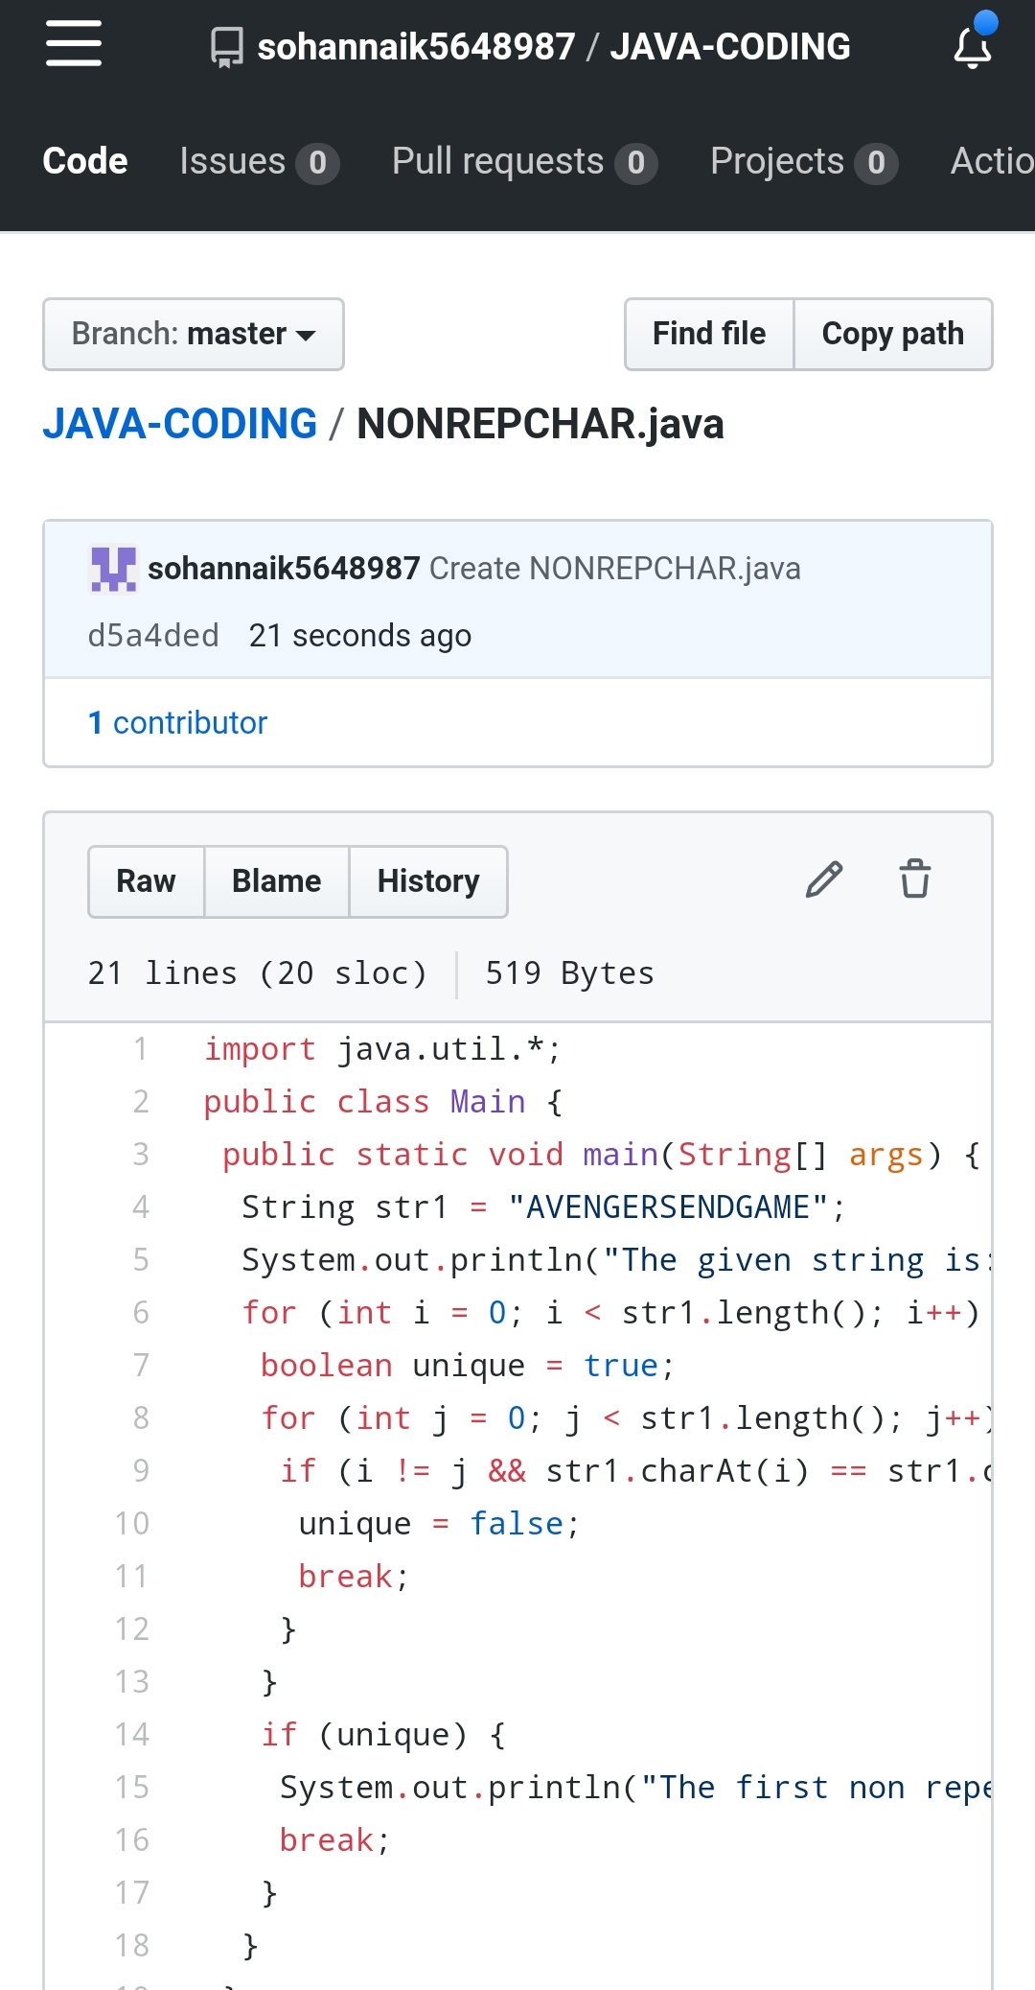

REPOSITORY LINK:https://github.com/sohannaik5648987/JAVA-CODING

https://github.com/sohannaik5648987/C-CODING